# Simulink PX4 Link

Simulink interface that uses MAVLink messages to establish a link between PX4 flight stack (sending setpoints/commands and receiving telemetry) and Vicon Motion Capture (position and attitude).

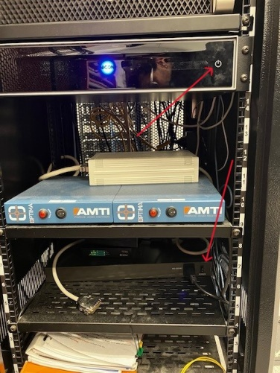_Written by:_ Pedro Mendes, 2019/08/29 - pmen817@aucklanduni.ac.nz

_Last modified:_ Pedro Mendes, 2022/08/31 - pmen817@aucklanduni.ac.nz

### Vicon Instructions:

1. Turn on all cameras;

2. Turn on TV and wireless receiver to cast monitor screen; **(optional)**

3. Open Vicon Tracker software:

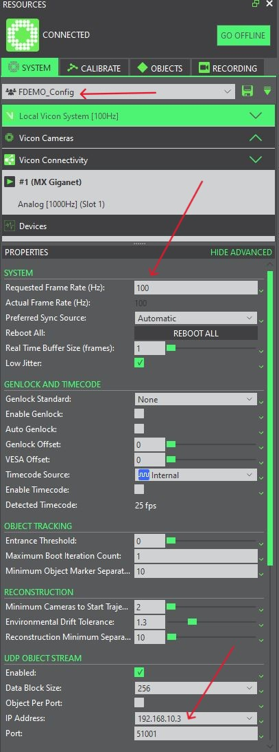

4. Select profile **FDEMO_Config**

(or create a profile with the following settings - make sure profile is saved as a Shared profile). **If

using a separate computer to run the Tracker set 'IP Address' to 192.168.10.3**:

5. Calibrate cameras if necessary (if cameras lost calibration, usually after cameras are reoriented/moved). **Origin calibration must always be verified before a flight session.**

**CALIBRATION**

5.1. MASK - Remove markers/drones from the center of the room (camera field of view), click START, wait a few seconds, and then STOP;

5.2. CAMERAS - click START, use wand and wave it around so cameras can detect wand lights. Keep going until all cameras are calibrated (green);

5.3. ORIGIN - change view type to 3D perspective, place 3 markers in the allocated places on the ground, press CALIBRATE > SHOW ADVANCED (SET VOLUME ORIGIN) > SET (Three Markers), select origin, primary axis and secondary and check if final orientation is correct;

6. Select (**TD2 and MUG**) or create desired objects to be tracked > Press "Track" button;

6.1 . Create object:

6.1.1. Create the object by selecting all markers and giving an object name.

6.1.2. Pause the tracking (button highlighted in image below) and define Global Rotation:

**IMPORTANT 1: Object's body frame MUST match Vicon/Inertial Frame (image below). **

**IMPORTANT 2:** Global Z Position should be set to 0 when drone is placed on the ground (not required if setpoints are adjusted accordingly):

6.1.3. Unpause tracking and press "Track" button.

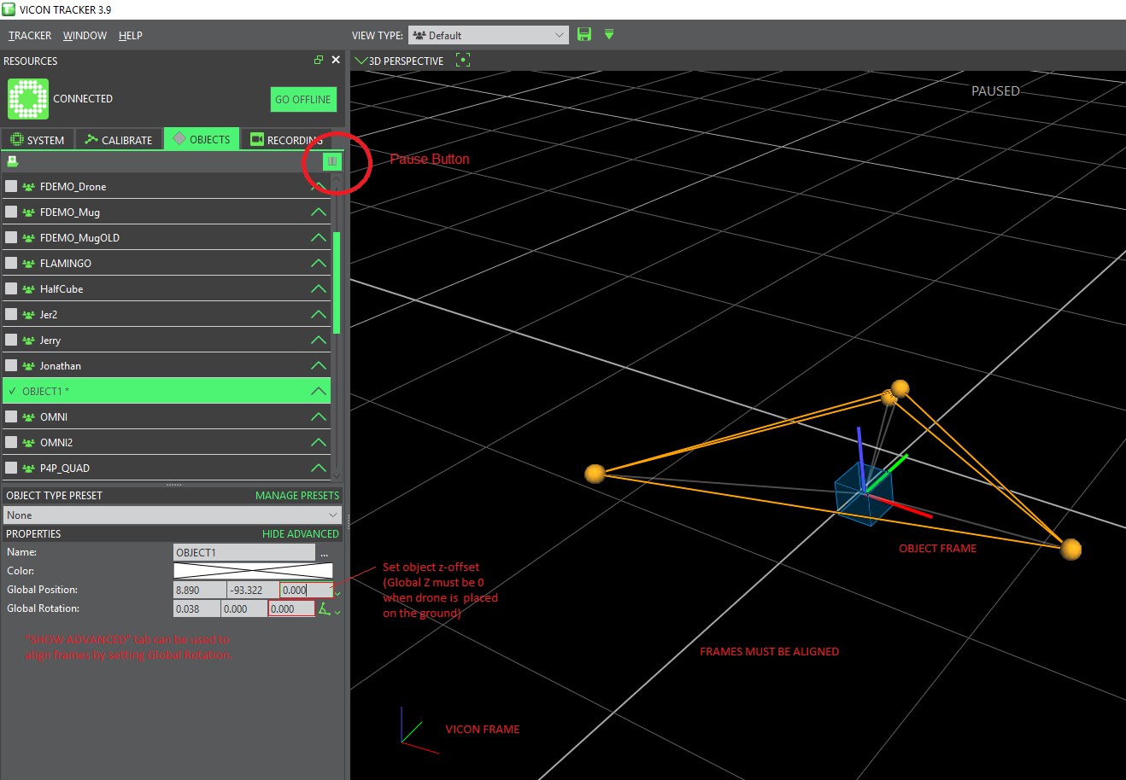

### PX4/WiFi Instructions

1. Power on UAV/Wifi module;

2. Connect to Wifi Module Access Point (go to http://192.168.4.1/ (for older modules) or http://192.168.2.1/ (for ESP32 DroneBridge modules) using an internet browser to access WiFi Module Bridge settings and verify port numbers if available (ESP32 DroneBridge are using 14550 and older modules 14551/14556));

3. Check if WiFi Module is set to Private network or you will not be able to use QGroundControl or Simulink (image below);

4. When using QGroundControl, connection to Wifi Module is established automatically. If that does not happen, connect the flight controller via USB and check if the baud rate parameter (e.g., SET_TEL1_BAUD) for the used telemetry port matches the Wifi Module baud rate (default value for ESP32 DroneBridge = 115200). To connect older modules (ports 14551/14556) use the following settings (after entering settings, select "UDP Link on Port 14551", and click "Connect":

5. **Make sure drone is properly configured and well-tuned** (only use Offboard mode after rigorous tests in Manual control);

6. Assign Offboard flight mode to a switch;

7. **IMPORTANT: Make sure the parameters below are set to the following values:**

* **EKF2_AID_MASK** = _24_ (Vision Position Fusion and Vision Yaw Fusion);

* **EKF2_HGT_MODE** = _Vision_;

* **SER_TEL1_BAUD** = _115200 8N1_ (should match baudrate found in WiFi Module Settings);

### MATLAB/Simulink Instructions

1. Power on UAV/WiFi module;

2. Connect to Wifi Module Access Point;

3. Open Matlab

4. Run the script "_run_px4_vicon_demo.m_" - this will check if all packages are installed, create header files, and compile function;

5. In the dialog box, type the object name to be tracked (THIS MUST MATCH THE OBJECT NAME CREATED IN VICON TRACKER). Object1 is the main object, it can be tracked and receive setpoints. Object2 is only tracked - no setpoints are sent to this object.

6. Run simulation (make sure QGroundControl is not connected to the WiFi module)

7. Before flight, **ALWAYS check if telemetry data is converging to Vicon data** (PX4 must be powered on): Mocap and UAV led GREEN

8. Place the MUG in the desired origin location and PRESS “Set origin” (on and off)

9. Press the FOLLOW MUG switch

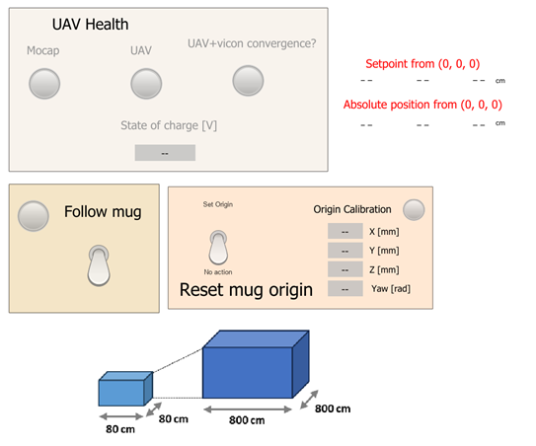

10. Switch flight mode to Offboard using RC switch. **IMPORTANT: it is good practice to increase throttle as close as possible to hover throttle before engaging Offboard mode - that guarantees the drone will not free fall in case Manual flight mode needs to be reengaged before landing or it failsafes**;

13. After landing, switch back to manual/stabilized flight mode, disarm, and then stop simulation;

14. Logged signals are saved in workspace as _logsout_. Save this variable before running simulation again if you want to keep a record of logged signals (**the _logsout_ variable is overwritten everytime the simulation starts**).